
W-16
12 PHYSICS ATAR
TEST 4 - MOTION

NAME: MARK: 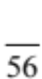

Instructions:
Assume negligible air resistance unless the question explicitly asks you to consider for real situations or qualitative arguments.

1. Two baseballs in the figure below were hit with the same initial speed of 25.0 ms⁻¹.

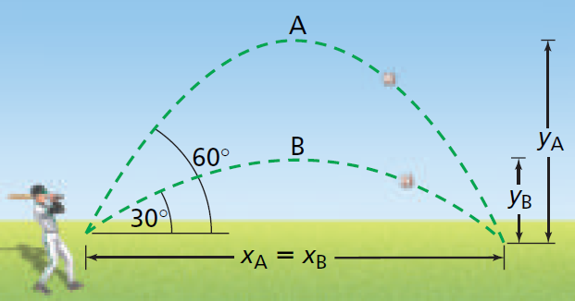

(a) For trajectory A, determine the magnitude of the:

(i) horizontal component of the initial velocity. (1 mark)

(ii) vertical component of the initial velocity. (1 mark)

(b) For trajectory B, determine the magnitude of the:

(i) horizontal acceleration. (1 mark)

(ii) vertical acceleration (1 mark)

(c) For both trajectories, which graph shows:

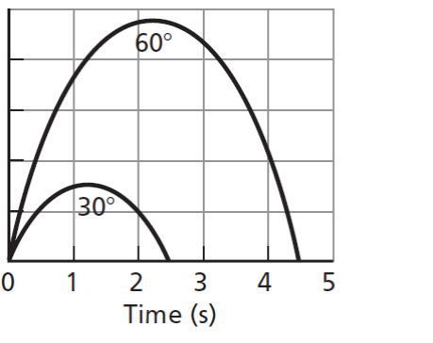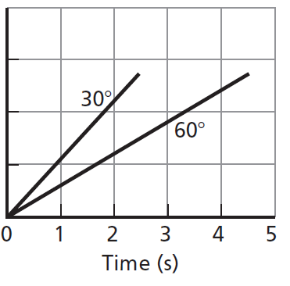
Graph 1 Graph 2

(i) the horizontal distance travelled versus time. (1 mark)

(ii) the vertical distance travelled versus time. (1 mark)

(iii) Using the equations of motion, calculate the time of flight of trajectory A (projected at 60°). (2 marks)

(iv) Calculate the maximum height reached in trajectory A (projected at 60°). (2 marks)

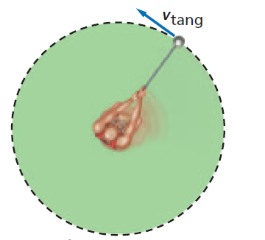
2. An athlete whirls a 7.00 kg hammer of radius 1.80 m from the axis of rotation in a horizontal circle as shown right.

(a) If the hammer makes one revolution in 1.00 s:

(i) calculate the centripetal acceleration of the
hammer? (3 marks)

(ii) state the direction of the centripetal acceleration? (1 mark)

(b) Determine the tension in the chain? (2 marks)

3.
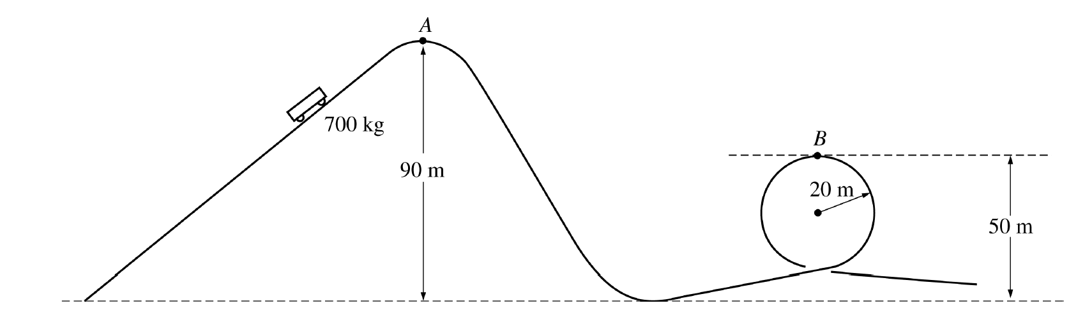

A roller coaster at an amusement park lifts a car of mass M kg to point A at a height of
90.0 m above the lowest point on the track, as shown above.

The car starts from rest at point A, rolls with negligible friction down the incline and follows the track around a loop of radius 20.0 m.

Point B, the highest point on the loop, is at a height of 50.0 m above the lowest point on the track.

(a) (i) Indicate on the figure the point P at which the maximum speed of the car is attained. (1 mark)

(ii) Calculate the value of this maximum speed. (3 marks)

(b) Calculate the speed of the car at point B. (3 marks)

(c) (i) On the figure of the car below, draw and label vectors to represent the forces acting on the car when it is upside down at point B. (3 marks)

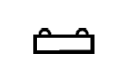

(ii) Calculate the magnitude of all the forces identified in (c) (i), given that M
is 7.00 x 10² kg. (3 marks)

(d) Assume that friction is not negligible. How could the loop be modified to maintain the same speed at the top of the loop as found in (b)?

Justify your answer. (2 marks)

4.
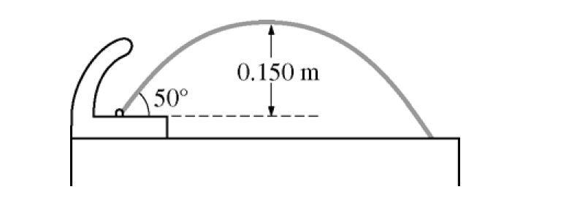

A drinking fountain projects water at an initial angle of 50.0º above the horizontal. The water reaches a maximum height of 0.150 m above the point of exit.

(a) Calculate the speed at which the water leaves the fountain. (4 marks)

(b) The radius of the fountain’s exit hole is 4.00 x 10⁻³ m. Calculate the rate of volume flow of the water. (2 marks)

5. A ball on a light string moves in a vertical circle. Analyse and describe the motion of this system considering the effects of gravity and tension using free-body diagrams. Is the system in uniform circular motion? Explain. (5 marks)

6. A car is travelling with speed v around a curve of radius r (shown left).

(a) Determine an equation for the angle θ at which a road should be banked so that no friction is required. Draw forces on the free body diagram to derive the equation.
(4 marks)

r

θ
θ

Free Body Diagram

(b) Calculate the angle for a road that has a curve of radius 50.0 m with a design speed of 50 kmh⁻¹. (2 marks)

7. Big Bertha was the name of a huge cannon used by the Germans in the First World War to fire across the Channel to England. This gun was mounted on a train and could be moved to different positions. The shell’s muzzle velocity was 7.50 x 10² kmh⁻¹.

40⁰

(a) What would be the maximum height that the shell reached above the ground? (2 marks)

(b) What is the range of the gun if the angle of elevation is 40.0°? (2 marks)

(c) What would be the gun’s maximum range when its angle of elevation can be increased or decreased? (2 marks)

(d) What would be the velocity and angle of the shell 5.00 seconds after firing? Assume the angle of elevation remains at 40.0°. (2 marks)

